**Wie viele Münzen sind in der BoX ?**

Bsp 1:

⬄

Gleichung:

|  |  |  |  |  |  |  |
| --- | --- | --- | --- | --- | --- | --- |
|  |  |  | ⬄ |  |  |  |
|  |  |  | ⬄ |  |  |  |

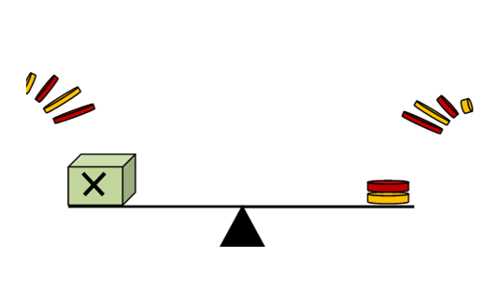

Bsp 2:

⬄

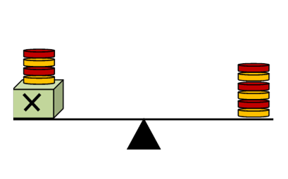

Gleichung:

|  |  |  |  |  |  |  |
| --- | --- | --- | --- | --- | --- | --- |
|  |  |  | ⬄ |  |  |  |
|  |  |  | ⬄ |  |  | __ |

Bsp 3:

⬄

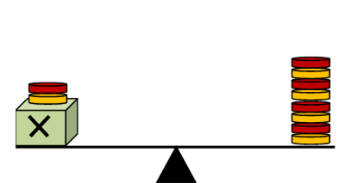

?

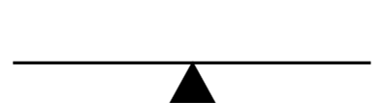

Gleichung:

|  |  |  |  |  |  |  |
| --- | --- | --- | --- | --- | --- | --- |
|  |  |  | ⬄ |  |  |  |
|  |  |  | ⬄ |  |  | __ |

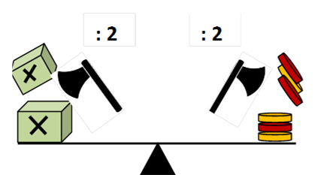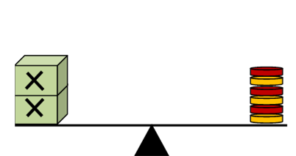**Wie viele Münzen sind in jeder BoX ?**

Bsp 4:

⬄

Gleichung:

|  |  |  |  |  |  |  |
| --- | --- | --- | --- | --- | --- | --- |
|  |  |  | ⬄ |  |  |  |
|  |  |  | ⬄ |  |  | __ |

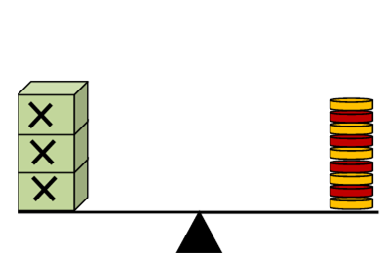

Bsp 5:

⬄

?

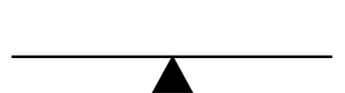

Gleichung:

|  |  |  |  |  |  |  |
| --- | --- | --- | --- | --- | --- | --- |
|  |  |  | ⬄ |  |  |  |
|  |  |  | ⬄ |  |  | __ |

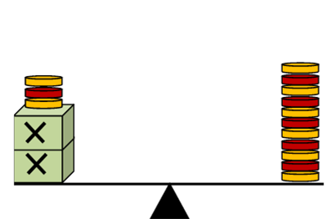

Bsp 6:

⬄

?



Gleichung:

|  |  |  |  |  |  |  |
| --- | --- | --- | --- | --- | --- | --- |
|  |  |  | ⬄ |  |  |  |
|  |  |  | ⬄ |  |  |  |
|  |  |  | ⬄ |  |  | __ |

**Wie viele Münzen sind in der BoX ?**

Bsp 1:

⬄

**L Ö S U N G E N**

Gleichung:

|  |  |  |  |  |  |  |
| --- | --- | --- | --- | --- | --- | --- |
|  |  |  | ⬄ |  |  |  |
|  |  |  | ⬄ |  |  |  |



Bsp 2:

⬄



Gleichung:

|  |  |  |  |  |  |  |
| --- | --- | --- | --- | --- | --- | --- |
|  |  |  | ⬄ |  |  |  |
|  |  |  | ⬄ |  |  |  |

Bsp 3:

⬄



?



Gleichung:

|  |  |  |  |  |  |  |
| --- | --- | --- | --- | --- | --- | --- |
|  |  |  | ⬄ |  |  |  |
|  |  |  | ⬄ |  |  |  |

**Wie viele Münzen sind in jeder BoX ?**

**L Ö S U N G E N**

Bsp 4:

⬄

Gleichung:

|  |  |  |  |  |  |  |
| --- | --- | --- | --- | --- | --- | --- |
|  |  |  | ⬄ |  |  |  |
|  |  |  | ⬄ |  |  |  |



Bsp 5:

⬄

?



Gleichung:

|  |  |  |  |  |  |  |
| --- | --- | --- | --- | --- | --- | --- |
|  |  |  | ⬄ |  |  |  |
|  |  |  | ⬄ |  |  |  |



Bsp 6:

⬄

?



Gleichung:

|  |  |  |  |  |  |  |
| --- | --- | --- | --- | --- | --- | --- |
|  |  |  | ⬄ |  |  |  |
|  |  |  | ⬄ |  |  |  |
|  |  |  | ⬄ |  |  |  |