WS 1 The cartoons tell the story
- Make a mind map after skimming the cartoons and find the topics of Greg`s story like school,, …
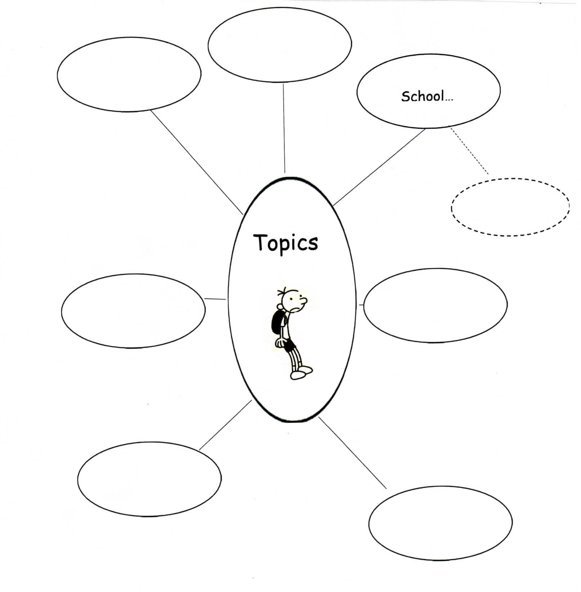
- Draw more fields and add more details.

