Replying to the letter on page 38
A worried mother and her two children have an argument over the consumption of meat. Her children want to become vegetarians, but she doesn’t want them to become vegetarians.
  - Understanding the letter
Look for the English equivalents in the text and write them down.
Neuigkeiten bekanntgeben – to break the news_________________________________
..., die gerade 12 Jahre alt wurde, ... - ___________________________________________
zahllose gesundheitliche Gründe - ______________________________________________
sich entwickeln / sich entfalten - ________________________________________________
ein großes gesundheitliches Risiko - ____________________________________________
Massentierhaltung – _________________________________________________________
anekeln / abstoßen - _________________________________________________________
Bio Fleisch - _______________________________________________________________
... wir könnten es uns nicht leisten. - ____________________________________________
seine größte Sorge - ________________________________________________________
Zerstörung des Regenwaldes - ________________________________________________
es würde mir nichts ausmachen ein bisschen weniger Fleisch zu essen - _________________________________________________________________________
ein großer Fehler - __________________________________________________________

1.2 Talking about statements from the letter
Find a partner / partners and discuss the following statements, which are taken from the letter
to Mara. Use some of the words and expressions from the list above as well as from the list below.
to live close to nature / to live in harmony with nature – naturnah leben / im Einklang mit der Natur leben; alternative – Alternative; delicious – köstlich; behaviour – Verhalten; habit - Gewohnheit

Statement 1: “We humans evolved because we ate meat. It’s against nature to go without it completely.” Discuss if you agree or disagree.

Statement 2: “The kind of factory farming we have in this country today disgusts her. […] it’s just one of those things we have to accept.” Discuss if you agree or disagree that we have to accept factory farming.

Statement 3: “I wouldn’t mind cutting down a bit on meat.” What about you? Would it be
hard for you to cut down on meat?

1.3 Information on meat consumption and vegetarianism
Read the following texts.
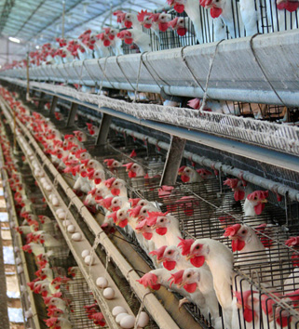
a) Health: If a vegetarian diet (eine vegetarische Ernährung) is balanced and includes cheese, nuts, lentils (Linsen), soy (Soja), eggs and other sources of protein (Proteinlieferanten), then it is just as healthy as a diet that includes meat. Some scientists say that vegetarians are less likely to suffer from high blood pressure (unter Bluthochdruck leiden) and heart attacks. While our bodies certainly need enough protein, it shouldn’t be the biggest worry (die größte Sorge) when it comes to a healthy diet. One of the biggest health risks today is the high amount of sugar (große Menge an Zucker) that we consume. Consequently, people who worry about health risks should cut down on sugar (sollten ihren Zuckerkonsum reduzieren) and make sure they eat plenty of vegetables and fruits.
https://www.flickr.com/photos/agriculturasp/5811710792

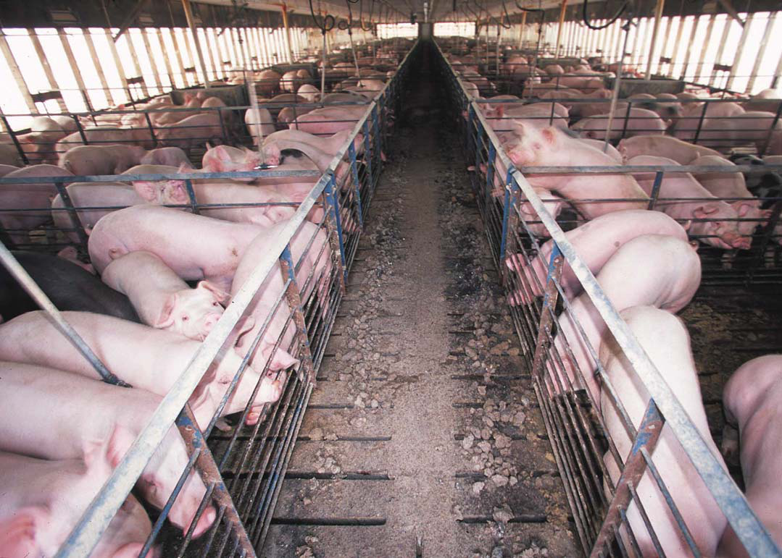
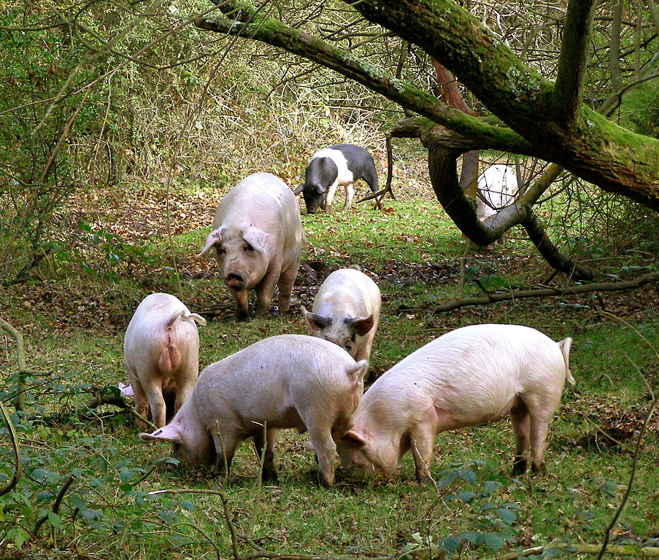
b) Treatment of animals: Most of the meat that is offered in supermarkets and restaurants comes from factory farms. Animals at factory farms are often under stress because they have very little room. As a consequence they sometimes attack each other or try to eat each other. These attacks can cause injuries (Angriffe können Verletzungen hervorrufen) and infections. That’s why many factory farmers cut off the beaks (Schnäbel) of chicken and remove the teeth of piglets (entfernen die Zähne von Ferkeln). But you can also get meat from animals that are allowed to move freely within and outside their barns (außerhalb ihrer Ställe). These animals are called free-range animals (freilaufende Tiere). Meat from free-range animals is usually more expensive than meat from factory-farmed animals (Tiere aus Massentierhaltung).
https://commons.wikimedia.org/wiki/File:Hog_confinement_barn_interior.jpg
https://commons.wikimedia.org/wiki/File:PB125758.jpg

c) Destruction of the rainforest: The average European (der durchschnittliche Europäer) consumes 61 kg of soy each year. Not directly, but indirectly, because we eat meat. Animals at factory farms eat a lot of soy and most of the soy that they eat is grown on fields in South America (wird auf Feldern in Südamerika angebaut), on areas that used to be rainforest (auf Gebieten, die früher Regenwald waren). This means that when we eat factory-farmed meat, especially chicken and pork, we indirectly destroy the rainforest in South America.

  - Collecting words and phrases from the texts
Fill in the table below. You can find the English equivalents in the texts.
English | German
sources of protein | Proteinlieferanten
 | unter Bluthochdruck leiden
 | die größte Sorge
 | eine vegetarische Ernährung
 | große Menge an Zucker
 | die Zähne von Ferkeln entfernen
 | freilaufende Tiere
 | den Zuckerkonsum reduzieren
 | Angriffe können Verletzungen hervorrufen
 | Tiere aus Massentierhaltung
 | wird auf Feldern in Südamerika angebaut
 | Soja
 | der durchschnittliche Europäer
 | Gebiete, die früher Regenwald waren

1.5 Questions on the texts
Underline those sentences which are correct according to the texts.
- Vegetarians usually have a high blood pressure.
- Cheese, nuts, lentils and eggs contain a lot of protein.
- Animals in factory farms don’t have enough room so they sometimes attack each other.
- In these attacks, the animals use their beads and teeth.
- Most of the meat that you can buy in supermarkets is from free-range animals.
- Free-range animals eat a lot of soy.
- Most of the meat from factory-farmed animals comes from South America.

  - Planning an anwer
Read the letter on page 38 again and write down arguments that the children and the mother give. Then use your knowledge and react from the perspective of the agony aunt.
arguments for / against vegetarianism | agony aunt’s reaction / answer
the children say a vegetarian diet is healthier | We need enough protein. Meat contains protein, but so do eggs, lentils, etc.. You should worry about sugar, not about meat.
  - Completing phrases that you could use in your letter
When you complete the phrases, you can use your notes from exercise 1.6. Keep in mind that an agony aunt typically shows understanding for every opinion or position, but that she also clearly states what she thinks is right and wrong.

- Thanks for writing to me______________________________________________
- Your letter reminded me (erinnerte mich) of my own kids, they also__ _______________________________________________________________________
- When I read your letter, I thought of _________________________________
- I can understand that you’re worried, but____________________________
_______________________________________________________________________
- Your daughter is right when she says that_____________________________
_______________________________________________________________________
- It’s also quite right that_______________________________________________
_______________________________________________________________________
- If you want to make sure that your children ‘s diet is healthy, then___
_______________________________________________________________________
- In your letter you said that your son wanted to_______________________
_______________________________________________________________________
- You can be proud of your children, they are __________________________
_______________________________________________________________________
- If we all ate less meat, this would be good for _________________________
---simple past in the if-clause--- ---would/could/might in the main clause---
_______________________________________________________________________
- You’re quite right when you say that organic meat is expensive. What you could do is ______________________________________________________
- ______________________________________________________________________

  - Connectives
Find the connectives in the texts on meat consumption and vegetarianism and write them down. Collect more connectives.
consequently,________________________________________________________
_________________________________________________ _________________
______________________________________________________________________

  - Writing an answer – first version
Dear worried mother,
_________________________________________________________________
_________________________________________________________________
_________________________________________________________________
_________________________________________________________________
_________________________________________________________________
_________________________________________________________________
_________________________________________________________________
_________________________________________________________________
_________________________________________________________________
_________________________________________________________________
_________________________________________________________________
_________________________________________________________________
_________________________________________________________________
_________________________________________________________________
_________________________________________________________________
_________________________________________________________________
_________________________________________________________________

2.2 Feedback:
In your feedback, tell your classmate
+ if he /she has referred to both the mother’s worries and the children’s opinion
+ if he / she has used the given information on health, animal treatment and the destruction of the rainforest
+ if you think his / her letter might help the worried mother
_________________________________________________________________
_________________________________________________________________
_________________________________________________________________
_________________________________________________________________
_________________________________________________________________
_________________________________________________________________

  - Writing an answer – second version
Dear worried mother,
_________________________________________________________________
_________________________________________________________________
_________________________________________________________________
_________________________________________________________________
_________________________________________________________________
_________________________________________________________________
_________________________________________________________________
_________________________________________________________________
_________________________________________________________________
_________________________________________________________________
_________________________________________________________________
_________________________________________________________________
_________________________________________________________________
_________________________________________________________________
_________________________________________________________________
_________________________________________________________________
_________________________________________________________________
_________________________________________________________________
_________________________________________________________________
_________________________________________________________________

