1. Both Maya and Josh are very surprised that Greg isn’t interested in the biscuit, because he’s so fond of food and eats most of the time. Something must be wrong with Greg. Write down 6 questions that Maya and Josh could ask Greg to find out what’s wrong with him. You can start your questions like this:
©Ernst Klett Verlag GmbH

Have you been ... / When was the last time you ... / Are you ... / Did you ... / Why ... / Do you want to ...
1.________________________________________________________________________________
2. _______________________________________________________________________________
3. _______________________________________________________________________________
4. _______________________________________________________________________________
5. _______________________________________________________________________________
6. _______________________________________________________________________________

2. The following quotes are taken from the conversation between Greg, Maya and Josh. Read the quotes and arrange them in the order in which they appear in the conversation.

Trust me. (Vertrau mir.)
Greg, have a biscuit. (Nimm einen Keks.)
I’m not hungry.
Come on, Greg, you can tell us. (Los, Greg, du kannst es uns erzählen.)
Ok, you’re scaring me. What’s wrong? (Du machst mir Angst.)
But promise me you won’t tell anyone. (Versprich mir, dass du es niemandem erzählen wirst.)

3. The following text is the conversation between Maya, Josh and Greg. Behind each statement, write down the name of the person who utters it.

Hey, Greg, you haven’t said anything today. Hello, Greg! Josh
Hey, Greg, have a biscuit.
I’m not hungry.
Ok, you’re scaring me. What’s wrong?
Nothing’s wrong.
Come on, Greg, you can tell us.
But promise me you won’t tell anyone.
I promise.
Trust me.
Well, since Friday, everything has been so different. On Friday I saw her.

She really is the most beautiful girl I have ever seen. She’s like an Indian goddess.

Wow, you’re in love. Who is she?
But promise me you won’t tell anyone. Her name is Chetna.
Have you asked her out on a date yet?
I wish I knew more about Asian culture, then maybe I’d have more of a chance.
That’s the silliest thing I have ever heard.
Wait a minute, Greg. I have a friend who is Asian. Her name is Ashna. I’m sure she could teach you about her culture.

Really?
Yeah. The problem is she lives in Manchester now. But I’m sure we could visit her there.
Wait a minute. Perhaps we can kill two birds with one stone. Let’s make a film about Asian culture and cultural differences in Manchester.

But don’t tell your friend I’m in love.

4. The conversation between Maya, Josh and Greg is about Greg being in love. Yet many expressions that Maya, Josh and Greg use could also be used in conversations about other topics. Write down all the expressions that you could use in conversations about other topics. Add the German translation.

Have a biscuit. - Nimm einen Keks. / Iss einen Keks.
Nothing’s wrong. - Alles in Ordnung. / Alles klar.____
__________________________________________________________________
__________________________________________________________________
__________________________________________________________________
__________________________________________________________________
__________________________________________________________________
__________________________________________________________________
__________________________________________________________________
__________________________________________________________________
__________________________________________________________________

5. Some of the sentences that Maya, Josh and Greg utter are in the present perfect (Greg, you haven’t said anything today.). Write down all the sentences in the present perfect. Use the speech bubbles.
Greg, you haven’t said anything today.

©Ernst Klett Verlag GmbH

©Ernst Klett Verlag GmbH

©Ernst Klett Verlag GmbH

In the following conversation, Josh and Greg talk about their friendship.
6.1 Underline all the expressions that you could possibly use in a conversation about promises.
6.2 Write down all the underlined expressions in a list and add the German equivalents.

Greg: It might be a strange thing for a boy to say, but you are the only person that I really trust.
Josh: How come you trust me? I publish everything you say on Facebook.
Greg: Very funny indeed. No, I really mean what I say. You are a true friend. And I have told you things that I have never told anybody else.
Josh: Have I ever made a promise that I would keep your secrets?
Greg: I thought you had. Maybe not. So who knows of all my tattoos?
Josh: I didn’t know you had tattoos.
Greg: I was just kidding.
Josh: It’s about time for you to get a tattoo. Every super surfer has a tattoo.
Greg: Well, I promised my parents I wouldn’t get a tattoo. And I always keep promises.
Josh: That’s what I like about you, Greg. I’ve never had a friend like you before.
Greg: Doesn’t Maya always say boys aren’t good at talking about their feelings. She’d be very proud of us.

English | German
You’re the only person I trust. | Du bist die einzige Person, der ich vertraue.

Josh says to Greg: At least there’s one thing all cultures have in common: girls love to gossip. (Es gibt zumindest eine Sache, die allen Kulturen gemeinsam ist: Mädchen tratschen gerne)
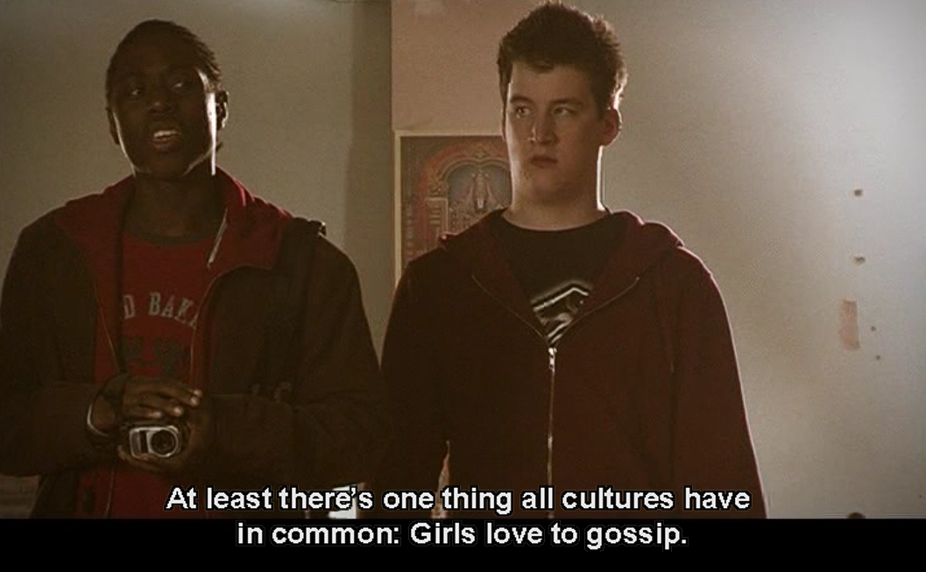
7. What do all cultures really have in common? Write down your ideas.
In all cultures, people _____________________________________________

What all cultures have in common is that _____________________________________________
©Ernst Klett Verlag GmbH

_____________________________________________

Something all cultures have in common is that ____________________________________________

_____________________________________________________________________________________

8. Summarize what happened in the film so far. In your summary, use the present tense and other tenses when necessary. You can start like this:

Greg tells his friends Maya and Josh that ____________________________________________
_____________________________________________________________________________
_____________________________________________________________________________
_____________________________________________________________________________
_____________________________________________________________________________
_____________________________________________________________________________
_____________________________________________________________________________
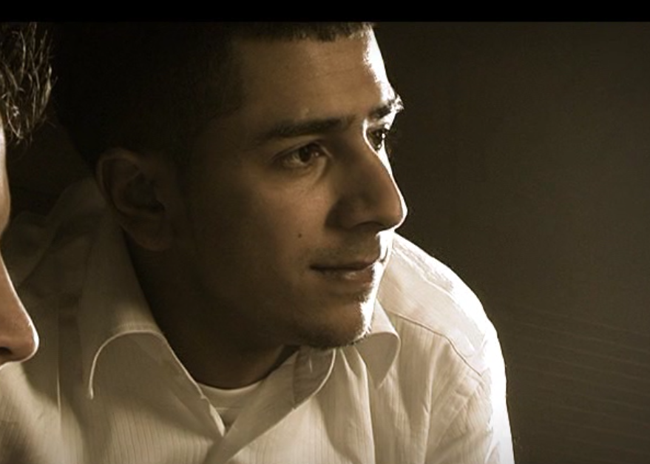
9. Speculate about the plot. Include Ashna, Greg and the waiter in your speculation. Use the will-future. You can start your sentences like this:
I think that Ashna will __________________________
_____________________________________________
_____________________________________________
©Ernst Klett Verlag GmbH
_____________________________________________
_________________________________________________________________________________
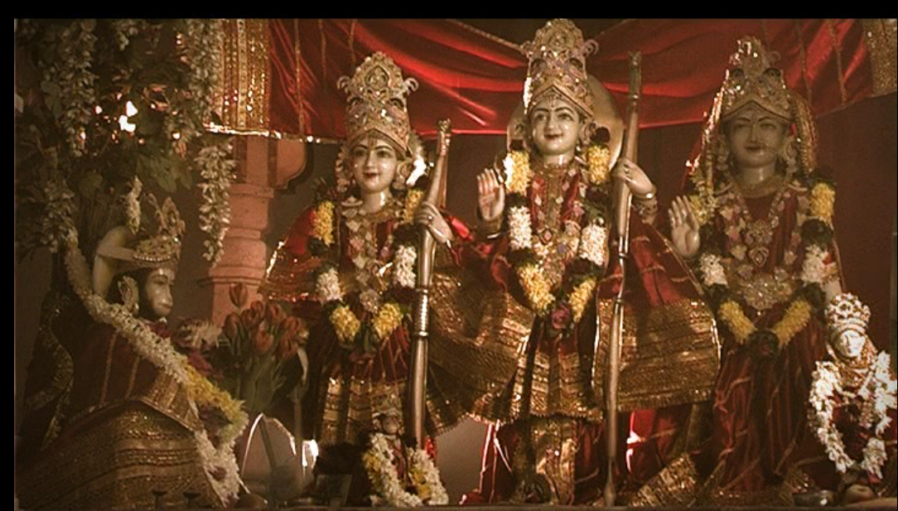
10. Write down what you learn about Indian culture in the movie. The film stills and the expressions in the boxes will help you. But be careful, not all the expressions are useful for this exercise.

a) _______________________________________
_________________________________________
_________________________________________
different gods / trust me / Have a biscuit. / Hindu religion / You’re scaring me. / Ganesh / I was just kidding. / the elephant god / Rama / to keep a secret

b) ____________________________________
©Ernst Klett Verlag GmbH
©Ernst Klett Verlag GmbH
______________________________________

_____________________________________

_____________________________________

_____________________________________
©Ernst Klett Verlag GmbH
Enjoy your meal. / traditionally / the right one / I wish I knew more about ... / as something dirty / I keep my promises / after going to the bathroom / to wash yourself

©Ernst Klett Verlag GmbH

c) ___________________________

_____________________________

_____________________________

_____________________________
©Ernst Klett Verlag GmbH
©Ernst Klett Verlag GmbH
Trust me. / You can tell us. / meat / vegetarian / to hurt animals / I’m not hungry / to be proud / I was just kidding
11. Give your own opinion about the first part of the film “Greg in Love”. You can use the words and phrases in the box below.

__________________________________________________________________________
__________________________________________________________________________
__________________________________________________________________________
__________________________________________________________________________
__________________________________________________________________________
__________________________________________________________________________
__________________________________________________________________________
__________________________________________________________________________
likeable – liebenswert predictable - vorhersehbar
character – Figur amusing - amüsant
surprising – überraschend boring - langweilig
humorous language – witzige Sprache I enjoyed watching the – Ich habe ... gerne angeschaut

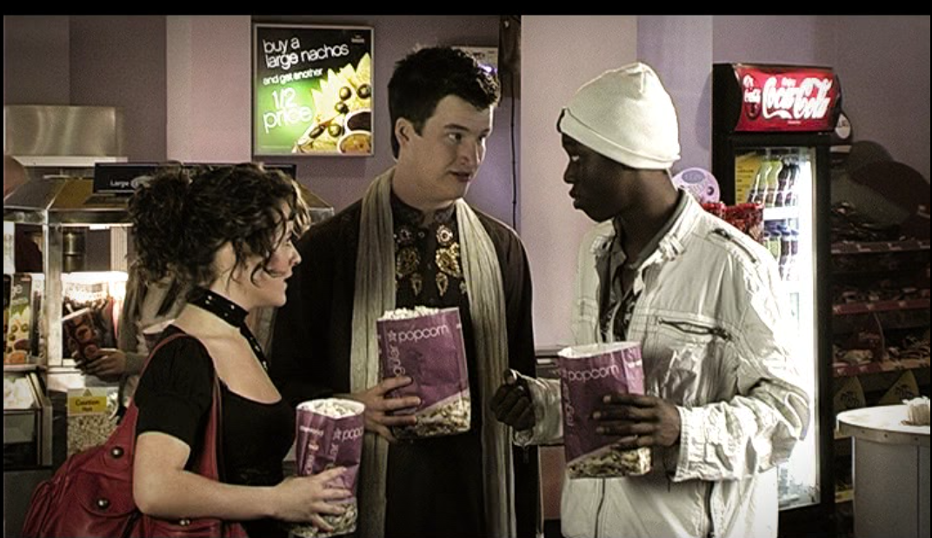
12. Complete the sentences below.
Josh: If I were you, Greg, I would _______________
____________________________________________
___________________________________________
Maya: If I were Chetna, I would ______________
©Ernst Klett Verlag GmbH
___________________________________________
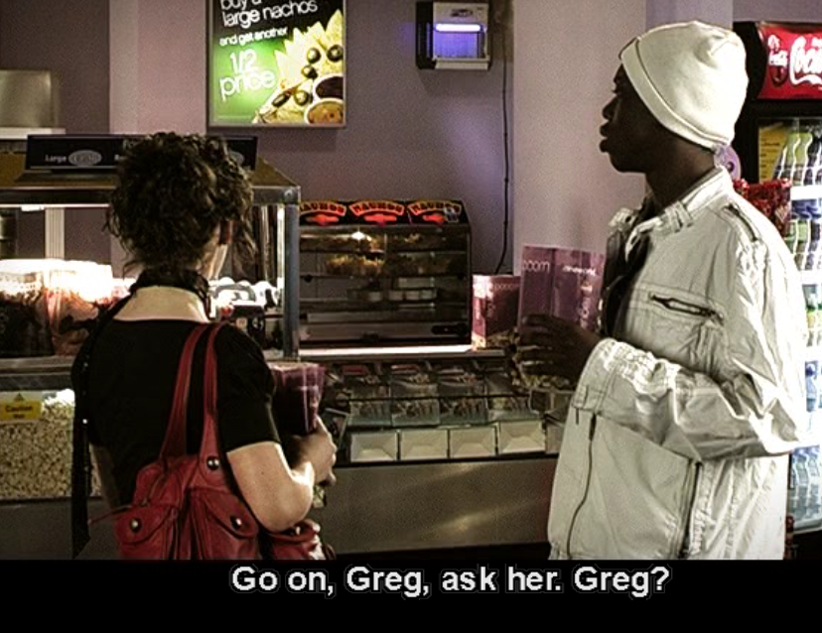
___________________________________________

13. What do you think is Greg doing? Speculate. Use the present progressive.
___________________________________________
___________________________________________
___________________________________________
___________________________________________
©Ernst Klett Verlag GmbH

14. Write down the conversation between Chetna and Aden, her boyfriend. Before you start writing, look again at exercises 4, 5 and 6. In your conversation, use the present perfect and use expressions from the list in exercise 6.

©Ernst Klett Verlag GmbH

________________________________________________________________________________________________
________________________________________________________________________________________________________________________________________________________________________________________________________________________________________________________________________________________________________________________________________________
_______________________________________________
_______________________________________________________________________________________________________________________________________
___________________________________________________________________________________________________________________________________________________________________________________________________________________________________________________________________________________________________________________________

Peer-assessment:
Give your classmate feedback on his or her dialogue.

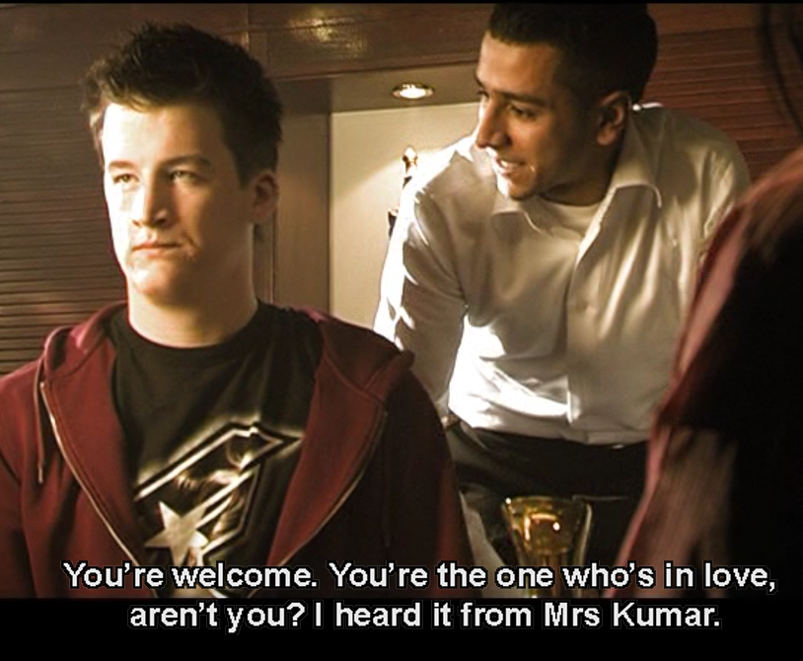
©Ernst Klett Verlag GmbH
Greg is angry with Maya, because she had
promised him she would not tell anyone about his secret and now even strangers know about it.

In the following dialogue, Greg tells Maya why he is so angry. Maya – on the other hand - tries to explain to him why she talked to Ashna about his secret.

15. Write this dialogue. Include expressions from exercises 4, 5 and 6.
©Ernst Klett Verlag GmbH

Greg: ____________________________________________________________________________
_________________________________________________________________________________
_________________________________________________________________________________
_________________________________________________________________________________
_________________________________________________________________________________
_________________________________________________________________________________
_________________________________________________________________________________
_________________________________________________________________________________
_________________________________________________________________________________
_________________________________________________________________________________
_________________________________________________________________________________
_________________________________________________________________________________
_________________________________________________________________________________
_________________________________________________________________________________
Peer-assessment:
Give your classmate feedback on his or her dialogue.

16. Continue the summary of the plot in “Greg in Love”. Use the present tense and other tenses when necessary.

In the short film “Cultural Differences”, Greg tells his friends Maya and Josh that he has fallen in love with Chetna, a British-Indian girl. He makes them promise that they don’t tell anyone about it. Greg wants to learn something about Indian culture, because he thinks that he would have more of a chance if he knew more about Indian culture. Maya, Josh and Greg decide to visit Ashna, a friend of Maya’s, who is British-Indian and who lives in Manchester. Once they have arrived in Manchester, they meet Ashna at a Hindu temple. It turns out that she already knows that Greg is in love. At first she explains to them the different gods in Hindu religion. Then …
______________________________________________________________________________
____________________________________________________________________________________________________________________________________________________________________________________________________________________________________________________________________________________________________________________________________________________________________________________________________________________________________________________________________________________________________________________________________________________________________________________________________________________________________________________________________________________________________________________________________________________________________________________________________________
____________________________________________________________________________________________________________________________________________________________
Peer-assessment:
Give your classmate feedback on his or her summary.

17. Write a film review of the film “Cultural Differences.”

“Cultural Differences” tells the story of Greg, a white British youth who falls in love with Chetna, a British Indian girl. The film starts out with a conversation between Greg and his two friends Maya and Josh. In this conversation, ______________________________________________________
_________________________________________________________________________________
_________________________________________________________________________________
_________________________________________________________________________________
_________________________________________________________________________________
_________________________________________________________________________________
_________________________________________________________________________________
_________________________________________________________________________________
_________________________________________________________________________________
_________________________________________________________________________________
_________________________________________________________________________________
_________________________________________________________________________________
_________________________________________________________________________________
_________________________________________________________________________________
_________________________________________________________________________________
_________________________________________________________________________________
_________________________________________________________________________________
_________________________________________________________________________________
Peer-assessment:
Give your classmate feedback on his or her dialogue.

