Sozial Media Prisma (Material 21)
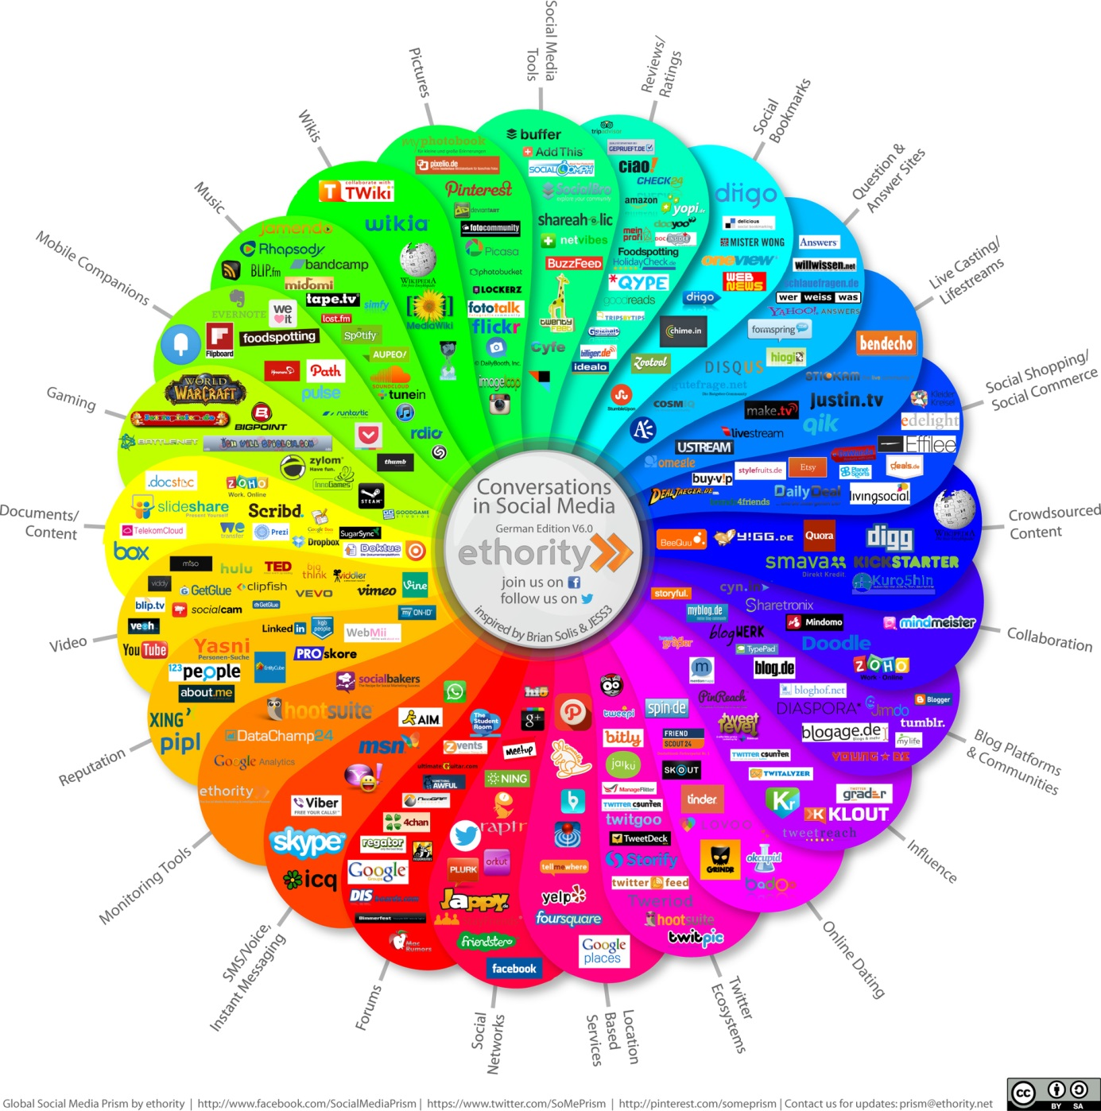

Social Media Prism by ethority; www.facebook.com/SocialMediaPrism; www.twitter.com/SoMePrism; http://printerest.com/someprism;
Contact us for updates:prism@ethority.net
Lizenz: CC-BY-SA-3.0

