2.2 Arbeitsblatt: Sticky Notes
In this exercise you can learn how to write a letter to a friend by using sticky notes you have prepared in advance.
Sample notes and letter:
These are sticky notes that a girl has jotted down to remember all that she wants to tell her friend in a letter:

Went on holiday in Spain
Passed
driving test
Busy year,
lots of new things
Still enjoying
baby-sitting

Bought my first scooter
Next time this letter as an email
Started class in computing
Hope you are well

Then she arranged them into the order she wanted for her letter:

Hope you are well
Still
enjoying
baby-sitting
Busy year,
lots of new things
Passed
driving test

Bought my first scooter
Next time this letter as an email
Started class in computing
Went on holiday in Spain

This is the letter she finally wrote:
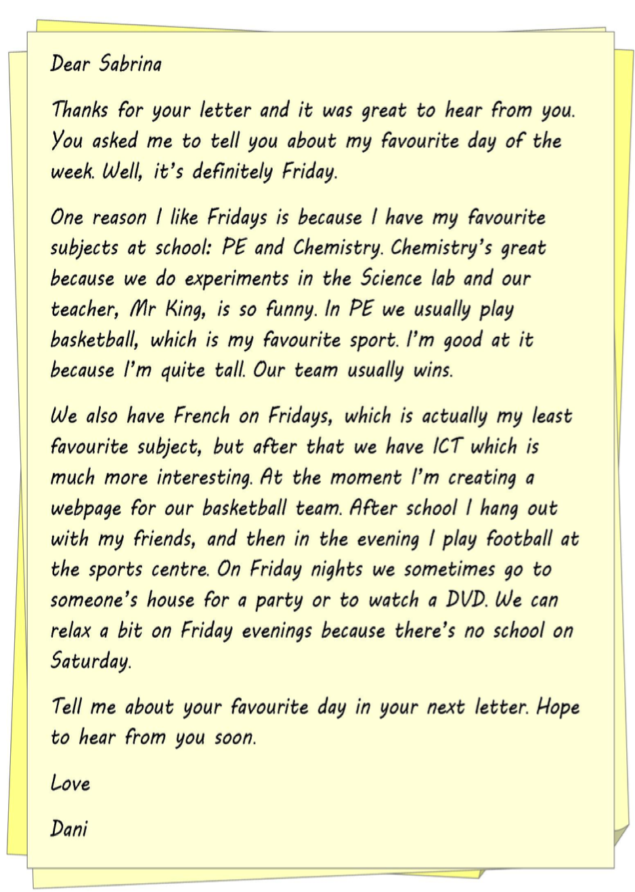

Dear Jane

Thanks for your letter and it was great to hear from you. You asked me what’s new with me. Well, here is some news. But before I’ll tell you – how are you? I hope you’re well, just like me.

I’ve really had a busy year so far and have done some really exciting things. First of all, I still do my baby-sitting regularly and can earn some extra money. So I took some driving lessons and I’ve passed my driving test recently.

Moreover, I could also afford to buy me my first scooter. Absolutely gorgeous! When you visit me the next time, we’ll be able to do some sightseeing on it in our region.

Oh, and went on holiday to Spain last June. It was fantastic. Great weather, blue sea and many, many good-looking guys down there. Maybe we should spend our next holidays together there!

Finally, I started an evening class in computing basics. You know, I’ve never been very interested in that sort of thing. Now I want to know all about it. So maybe my next letter will be an email. Don’t be surprised.

That’s it from my side. How about you? Hope to hear form you soon.

Love

Caroline

Now it’s your turn:
a) You are thinking about leaving school and looking for a job. Write what made you think so and what kind of job you are interested in and why. Use the sticky notes:
b) Now arrange the sticky notes in the order you want for your letter:
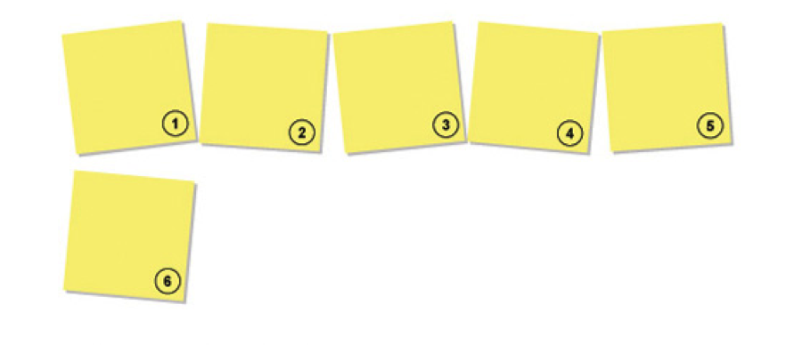
c) Now you are ready to write your first draft of a letter. Before you do so, check the sample letter for suitable phrases and expressions you can use for your own letter. List them below:

Your letter:

Dear

