Gap-filling 1 - nouns
- Read the text and for each gap in the text select the most appropriate word/phrase from the following list. Write the letters in the respective gap.

- Erhöhter Schwierigkeitsgrad:
Note that there are seven gaps, but nine words/phrases to choose from.

Soccer
- There follows a text about the pitch. Here is a sentence as an example:
The edges of the pitch are marked with ( ) and, at each end, ( ) .

( A ) centre spot
( B ) goal lines
( C ) referee
( D ) kick-off
( E ) sidelines
( F ) football pitch
( G ) corner
( H ) centre circle
( I ) halfway line

_____________________________________________________________________________
Erwartungshorizont
The edges of the pitch are marked with ( E ) and, at each end, ( B ) .
_____________________________________________________________________________

Gap-filling 2 - verbs
- Read the text and for each gap in the text select the most appropriate word/phrase from the following list. Write the letters in the respective gap.

- Erhöhter Schwierigkeitsgrad:
Note that there are seven gaps, but ten words/phrases to choose from.

Soccer
- There follows a text about the pitch. Here is a sentence as an example:
The edges of the pitch are marked with sidelines and, at each end, goal lines. A halfway line divides the pitch in two.

Möglichkeit zur Binnendifferenzierung:
Die gekennzeichneten Verben sind mögliche Lücken. Möglich ist, nur die Verben im „simple present“ zu prüfen. Um den Schwierigkeitsgrad zu erhöhen kann je nach Textvorlage „passive voice“, „present perfect“ oder/und „will-future“ ergänzt werden.

Mögliche Textquelle: Tell me about sport… football. Edwards, Nicola (ed.) Evans Brothers Limited 2009.

Multiple Matching - The pitch

Die Linien können mit Zahlen belegt werden und die richtigen Antworten mit Buchstaben (z.B. sideline – A). Dann kann eine Multiple Matching (geschlossene) Aufgabe dazu wie folgt lauten:

- Match the numbers with the correct parts of the pitch.

( A ) centre spot
( B ) goal line
( C ) penalty spot
( D ) sideline
( E ) corner
( F ) centre circle
( G ) halfway line

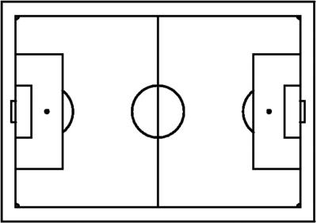
2
77
5
6
3
4
1

Erwartungshorizont
A – 5; B – 2; C – 6; D – 1; E – 3; F – 7; G – 4

