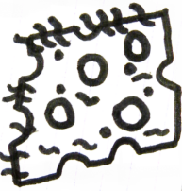
WS 4 The Cheese Touch

1. Answer the questions by finding the exact information in the text and quote:
Example:
- Why is there some cheese on the basketball court?
Quotation (p.9, lines 2- 3): “… it must’ve dropped out of someone’s sandwich.”
- How long has the piece of Cheese already been there?
( ):

- What does the cheese look like?
( ):

- What about playing basketball there on the court?
( ):

- Who started the Cheese Touch by doing what?
( ):

- What is the Cheese Touch like?
( ):

- Is there any protection against it?
( ):

- What was the effect of Greg’s taping up of his fingers?
( ):

- Where did the Cheese touch finally go?

2. What do you think about Greg’s worries that the Cheese touch might give him stress again? What would you tell him to help him get rid of that fear? Write a short piece of advice for him into your exercise books.

