M 4.1 (Basisfach) “Help me, I’m a loner!”
(Folie Arbeitsauftrag)

Walt and Thao have been invited to a talk show with the title, “Help me, I’m a loner”! In the show they have 2 minutes to first present themselves and then bring forward arguments why or why not
- they are in fact loners
- they are desperate about this and feel they need help

Afterwards, the audience is allowed to ask questions.

Preparing for the talk show

- In order to prepare for the first part, Walt and Thao are asked to fill in the following character card. However, the questions got all mixed up!
Using the phrases on the right for help, write down the questions from the grey box in an order that helps you present yourself in a structured way.

- Complete the first three boxes on the basis of what you have learned about Thao/Walt so far.

- Cut out the card. Using your notes and the phrases, present yourself to 2 other students with the same character. Give each other feedback and tips for improvement.

- Together, complete the last box.

- Together, think of five questions that you would like to ask the other character (Walt or Thao).

- On your own, practise your whole presentation three times, keeping in mind the feedback that the group has given you:
- Look at your notes and the phrases on the right.
- Fold your card, so that you can only see the notes, but not the phrases. Give your presentation again (including the phrases!).
- Give your presentation once more. Look at your character card only if necessary.

M 4.1 (Basisfach) “Help me, I’m a loner!”: preparing for a talk show
In order to prepare for the first part, Walt and Thao are asked to fill in the following character card. However, the questions got all mixed up!
Using the phrases on the right for help, write down the questions from the grey box in an order that helps you present yourself in a structured way.
List four adjectives that you would use to describe yourself (2 positive, 2 negative).
Which groups of people would you like to belong to? Why do you not belong?
Which group(s) of people do you have a sense of belonging with? Why?
List four adjectives that other people have used to describe you 2 positive, 2 negative).
What do you do in order to achieve a greater sense of belonging with them?
All in all, do you feel lonely? What do you do to cope with your loneliness?
How do you behave towards them? How do they behave towards you?
Do you think you need help? If yes: Who could help you? If no: Why do you think you can cope on your own?
Write down 3-4 things that are important to you. What are your aims in life?

My name is … and I would describe myself as…

Some people say I’m… because…

Some might say I’m… because

What makes me see value in life the most is…
In 5 years’ time, hopefully I will…

List four adjectives that you would use to describe yourself (2 positive, 2 negative).

I feel connected to…
I have a strong relationship with…
I feel confident about…

I feel disconnected from…
I feel rejected/ostracised by…
I feel left out because…

I’m struggling to belong with regard to…

I’m trying to find a way to belong by…

I have learned to cope with rejection/social exclusion by…

I think/ don’t think I need help because…

I’m quite happy on my own because…
I wish… would support me, but I don’t know how to…

M 4.1 (Basisfach) “Help me, I’m a loner!” - ANSWER KEY
Preparing for a talk show

My name is … and I would describe myself as…

Some people say I’m… because…

Some might say I’m… because

What makes me see value in life the most is…
In 5 years’ time, hopefully I will…

List four adjectives that you would use to describe yourself (2 positive, 2 negative).

List four adjectives that other people have used to describe you 2 positive, 2 negative).

Write down 3-4 things that are important to you. What are your aims in life?

I feel connected to…
I have a strong relationship with…
I feel confident about…

Which group(s) of people do you have a sense of belonging with? Why? How do you behave towards them? How do they behave towards you?

I feel disconnected from…
I feel rejected/ostracised by…
I feel left out because…

I’m struggling to belong with regard to…

I’m trying to find a way to belong by…

Which groups of people would you like to belong to? Why do you not belong?
What do you do in order to achieve a greater sense of belonging with them?

I have learned to cope with rejection/social exclusion by…

I think/ don’t think I need help because…

I’m quite happy on my own because…
I wish… would support me, but I don’t know how to…

All in all, do you feel lonely? What do you do to cope with your loneliness?
Do you think you need help? If yes: Who could help you?
If no: Why do you think you can cope on your own?

Fragen 1-4 SPT 41

M 4.1 (Leistungsfach) “Help me, I’m a loner!”
(Folie Arbeitsauftrag)

Walt, Thao and Sue have been invited to a talk show with the title “Help me, I’m a loner”! In the show they have 2 minutes to first present themselves and then bring forward arguments why or why not
- they are in fact loners
- they are desperate about this and feel they need help

Afterwards, the audience is allowed to ask questions.

Preparing for the talk show

- In order to prepare for the first part, Walt, Sue and Thao are asked to fill in the character card.
Take notes on the first 4 questions on your character card on the basis of what you have learned about Walt/Thao/Sue so far.
On the right, write down phrases you can use to present yourself and to talk about your relationships (MORE HELP: phrases to talk about belonging).
- Cut out the card. Using your notes and the phrases, present yourself to 2 other students with the same character. Give each other feedback and tips for improvement.

Together, answer the last two questions and write down helpful phrases. (MORE HELP: phrases to talk about relationships and belonging).

- Together, think of five questions that you would like to ask the other character (Walt, Sue or Thao).

- Now cut out the card. Practise your presentation three times:
- Look at your notes and the phrases on the right.
- Fold your card, so that you can only see the notes, but not the phrases. Give your presentation again (including the phrases!).
- Give your presentation once more. Look at your character card only if necessary.

M 4.1 (Leistungsfach) “Help me, I’m a loner!”
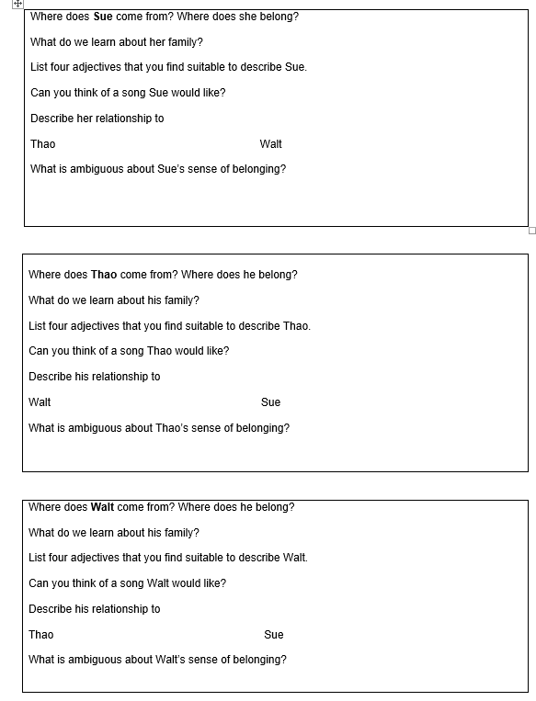

MORE HELP: phrases to talk about relationships and “belonging”

My name is … and I would describe myself as…

Some people say I’m… because…

Some might say I’m… because

What makes me see value in life the most is…
In 5 years’ time, hopefully I will…

I feel connected to…
I have a strong relationship with…
I feel confident about…
I feel disconnected from…
I feel rejected/ostracised by…
I feel left out because…

I’m struggling to belong with regard to…

I’m trying to find a way to belong by…
I have learned to cope with rejection/social exclusion by…

I think/ don’t think I need help because…

I’m quite happy on my own because…
I wish… would support me, but I don’t know how to…

Vorgehensweise vgl.: Schwerpunktthemenkommission der Regierungspräsidien Baden-Württemberg: The Ambiguity of Belonging. Gran Torino, S. 37; 41-42.
Material aus: Schwerpunktthemenkommission der Regierungspräsidien Baden-Württemberg: The Ambiguity of Belonging. Gran Torino, S. 41.

