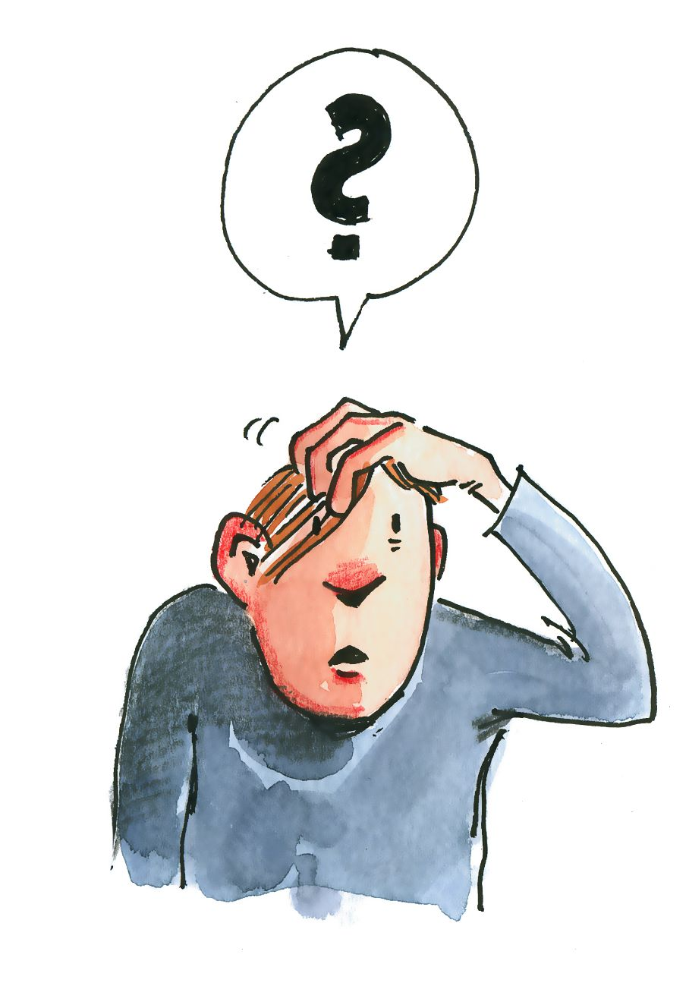
Thomas : « Il y a trop de choses bizarres dans cette histoire. » (p. 8) Lequelles ?
______________________________________________________________________________________________________________________________________________________________________________________________________________________________________________________________________________________________________________________________________________________________________________________________________________________________________________________________________________________________________________________________________


Où est papi ? Imagine une petite histoire !
__________________________________________________________________________________________________________________________________________________________________________________________________________________________________________________________________________________________________________________________________________________________________________________________________________________________________________________________________________________________________________________________________________________________________________________________________________________________________________________________________________________________

